

E-Project

**Web Booking**

**Railway Reservation System**

|  |  |
| --- | --- |
| **Authors** | **Aptech - C1810L - Group Sky** |
| 1. TRUONG DAC LOI – Student1155849 (Leader) 2. PHAM QUOC THINH - Student1163757 3. TRAN TRUNG KIEN - Student1070284 |
| **Centre Name** | Aprotrain Aptech |
| **Date** | 21th ,May 2021 |
| **Semester** | 3 |
| **Instructor** | LE HOANG ANH TUAN |

**HCM City, 21th May 2021**

Table of Contents

**PREFACE** 2

CHAPTER I: OVERVIEW 3

***1.*** ***Introduce the topic:*** 3

***2.*** ***Purpose of website:*** 3

***3.*** ***Some main pages:*** 3

CHAPTER II: DATABASE 4

***1.*** ***Database Structure Design for eProject*** 4

CHAPTER IV: INTERFACE SNAPSHOT 5

CHAPTER V: USER GUIDE 7

***1.*** ***Homepage*** 7

CHAPTER VI: ADMIN GUIDE 8

***1.*** ***Register:*** 8

***2.*** ***Login*** 8

***3.*** ***Get to Administrator View*** 9

***4.*** ***Manage Staff (Administrators)*** 9

***5.*** ***Manage Customer*** 10

***6.*** ***Booking train*** 11

***7.*** ***Railway name*** 11

***8.*** ***Main Station*** 12

***9.*** ***Information of the train*** 12

***10.*** ***Train schedule*** 13

***11.*** ***Train drill*** 13

***12.*** ***Seat Number*** 14

***13.*** ***Manage Payment Method*** 14

***14.*** ***Train Route*** 15

15

# **PREFACE**

Indian Railways is one of the largest rail networks in world. Majority of people used to travel in train which is convenient and affordable means of transport. So keeping this in view, the reservation of railways is a most important task and it must be faster and efficient as the demand (travelers) is very high. In order to meet this demand, manual reservation is cumbersome and it requires an efficient program to implement the online reservation.

This Application enables us to choose the train even there is no necessary to fill a form at the railway reservation counter ,i.e. we can directly select from the choices provided for us with train numbers and their origin, departure time, destination & arrival time at that station and the class to travel in. Application gives us the final output as train ticket with the amount to be paid.

The website is called Railway Reservation System. Through this we would like to express our sincere thanks and express gratitude to you dedicated instruction of teachers in the school "Aptech international programmer training system". Especially Mr. LE HOANG ANH TUAN, who directly instructed, taught and helped us during the implementation of this project.

# CHAPTER I: OVERVIEW

1. ***Introduce the topic:***

Business - buying is an indispensable need for each of us. In the current competitive era, the introduction of business products to individuals with low cost and high efficiency is a dilemma of business people with the demand for shopping with multi-products, Quality and affordability of consumers. So, our team conducted the website design to buy and sell goods online to help the stores grow faster, helping the store owners to manage their stores in a better way.

## ***Purpose of website:***

The goal of the website is to introduce and promote the Railway Reservation. Provide Customers know detailed information about Train such as go where, price, Train route ...

In addition, the website aims to introduce more known customers shopping, closing the gap and solving long-distance problems difficult travel or traffic congestion are more better.

## ***Some main pages:***

* **Home page**: This is an introduction page of the Railway Reservation. In addition, you can learn more about collections, hot shop promotions, links to page like booking, login, register, ,..
* **Booking**: This is the booking page to view and add seat number to cart if the customer want to use service.

CHAPTER II: DATABASE

1. ***Database Structure Design for eProject***

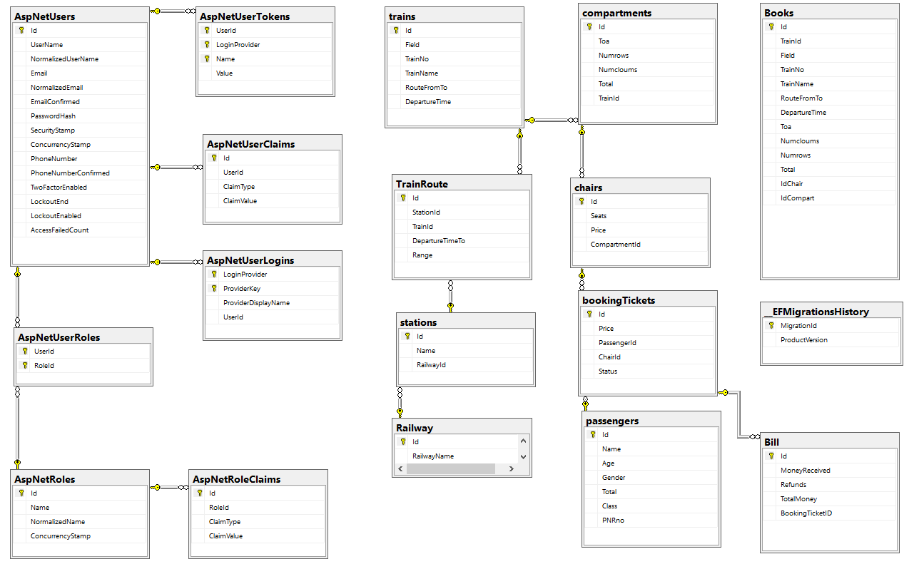

CHAPTER IV: INTERFACE SNAPSHOT

* **Home Page:**

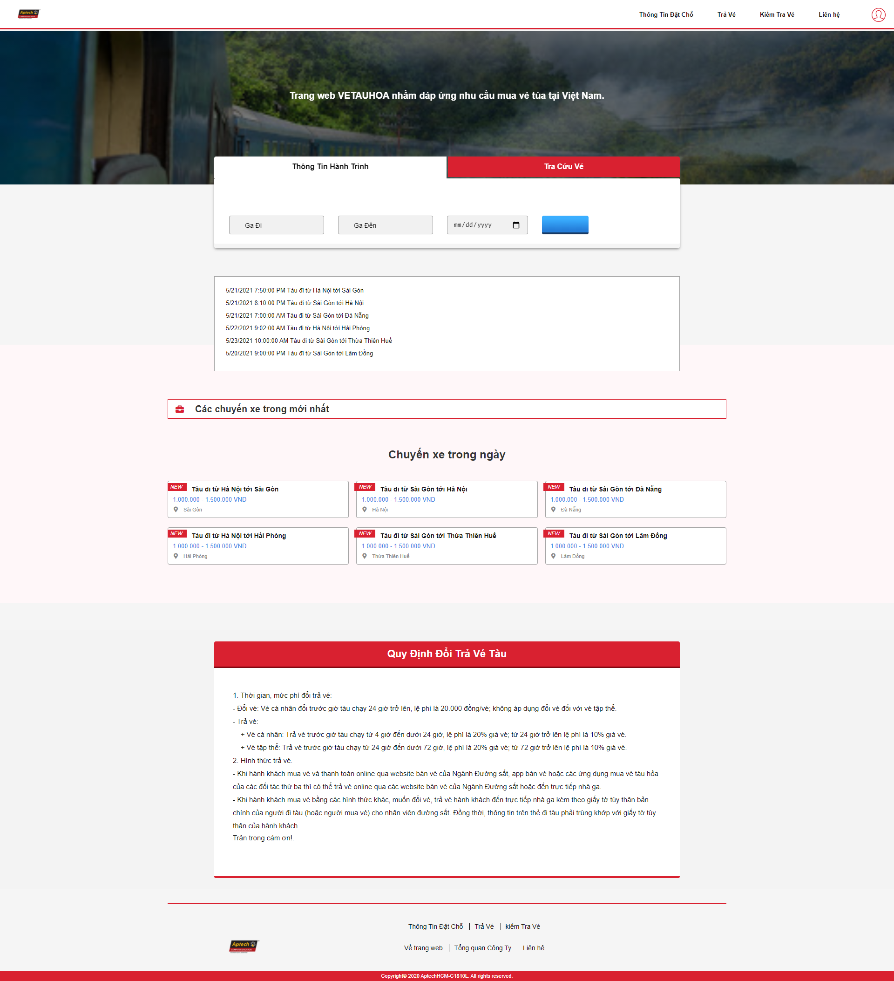

Figure 1: Homepage[

* **Select Train & booking seat**

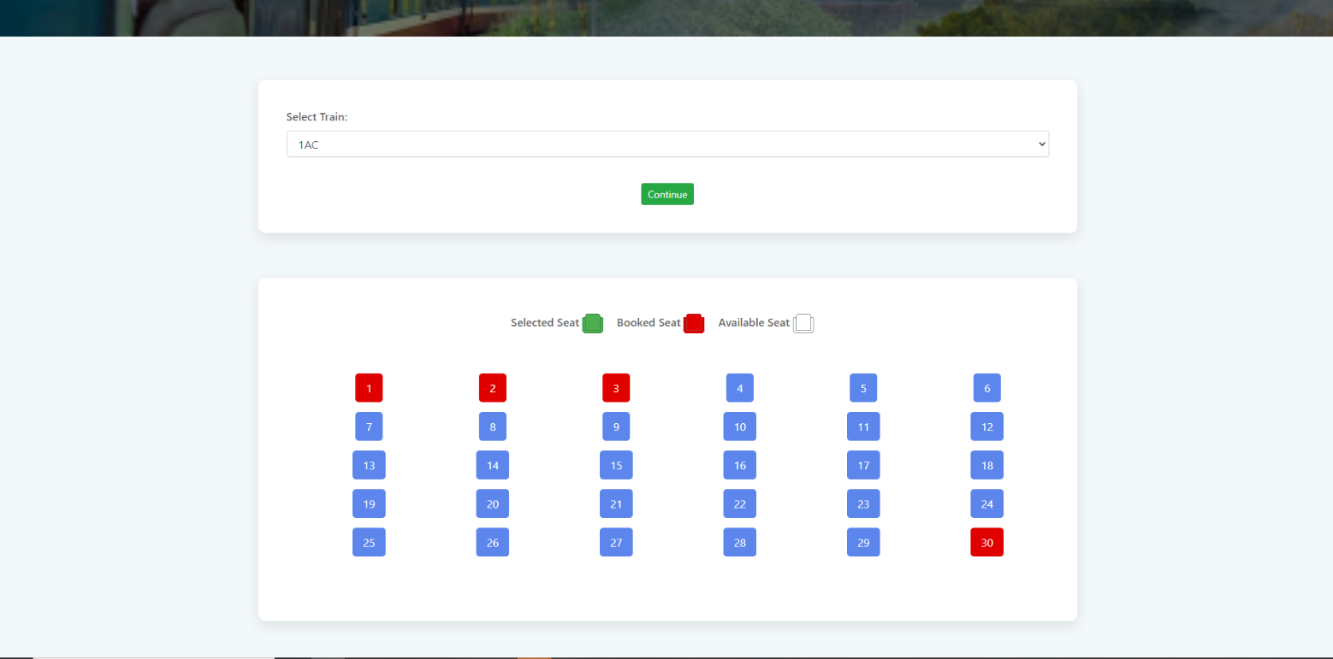

* **Information Ticket Booked & Payment:**

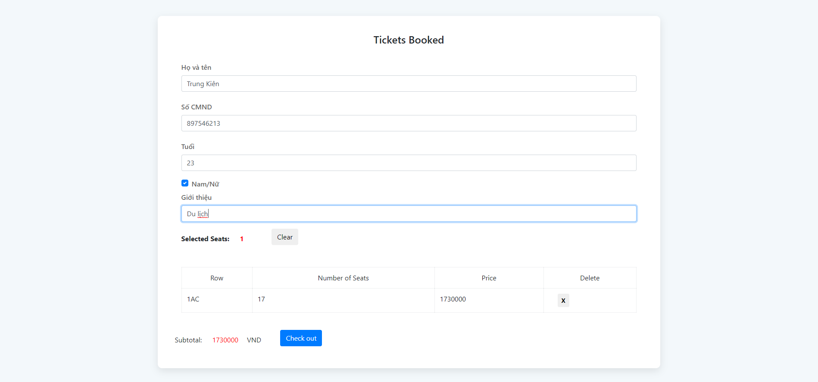

CHAPTER V: USER GUIDE

1. ***Homepage***



CHAPTER VI: ADMIN GUIDE

**Note:** In the system, there will be one super administrator who is already configured in the system. This user has full rights on all features within the system as well as manage all other administrators (Information about the super administrator will be provided in the Data_Initial_Script.sql).

1. ***Register:***

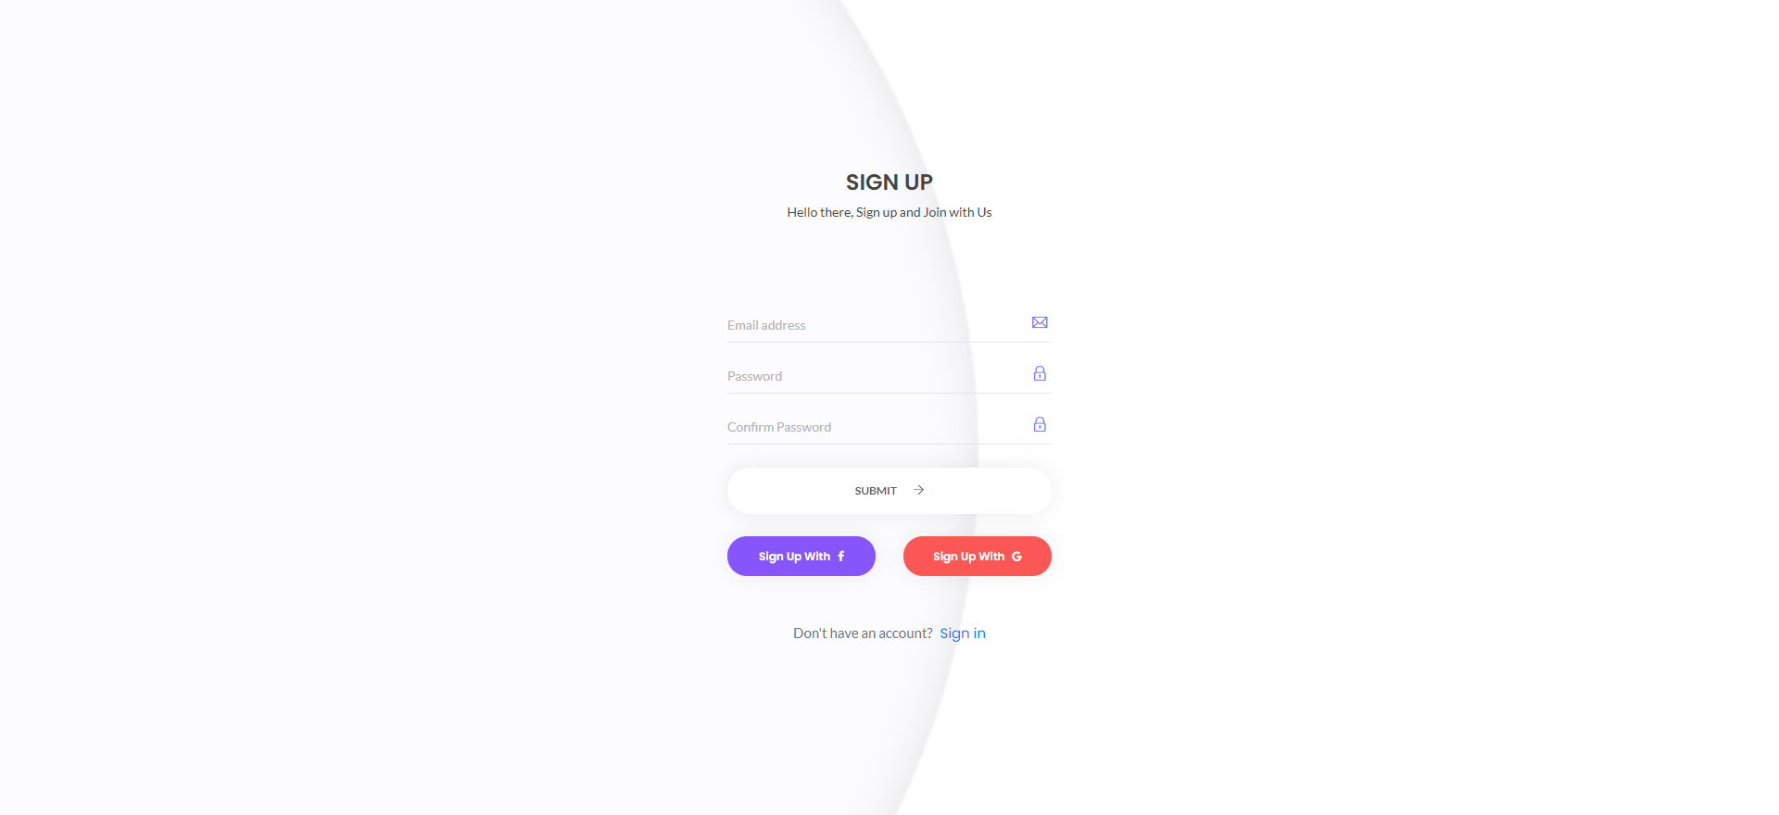

1. ***Login***

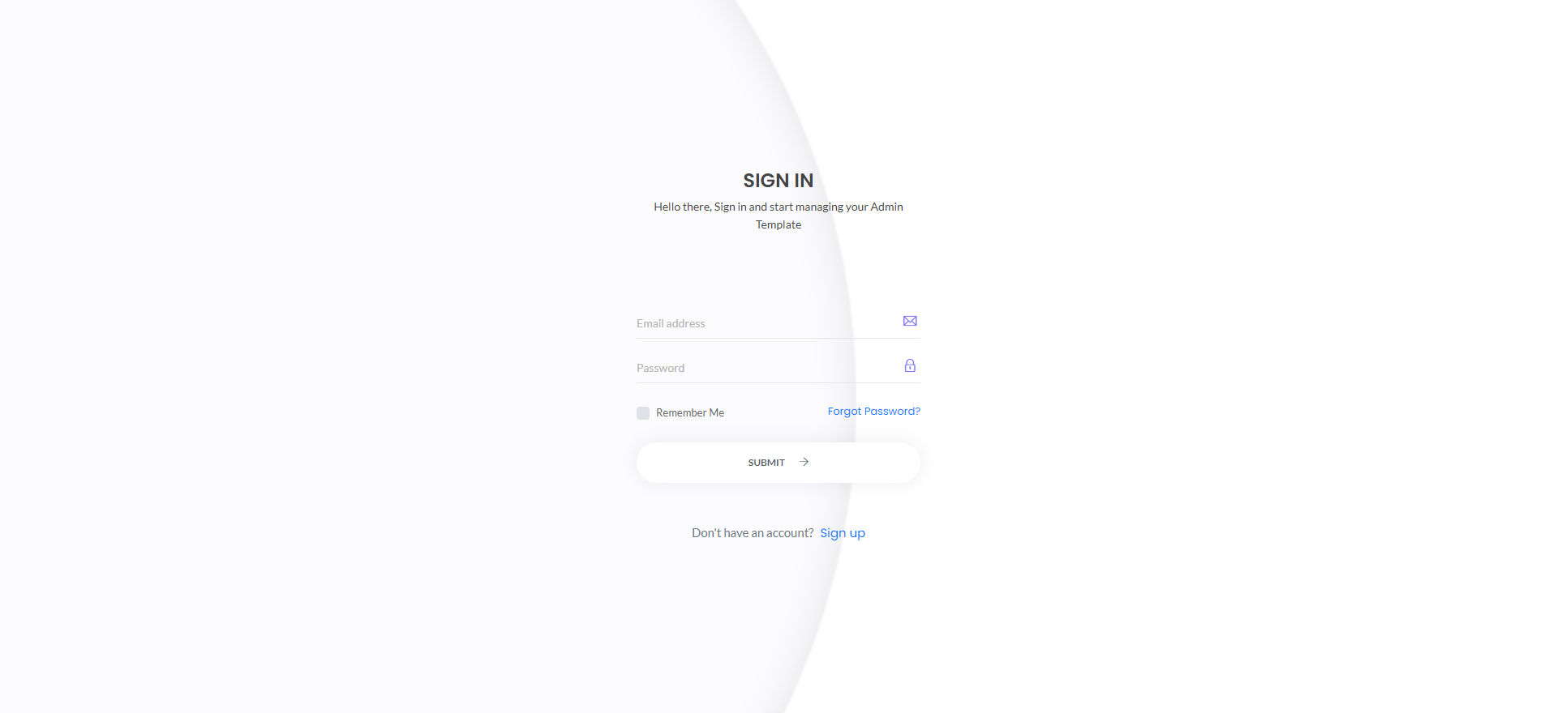

1. ***Get to Administrator View***

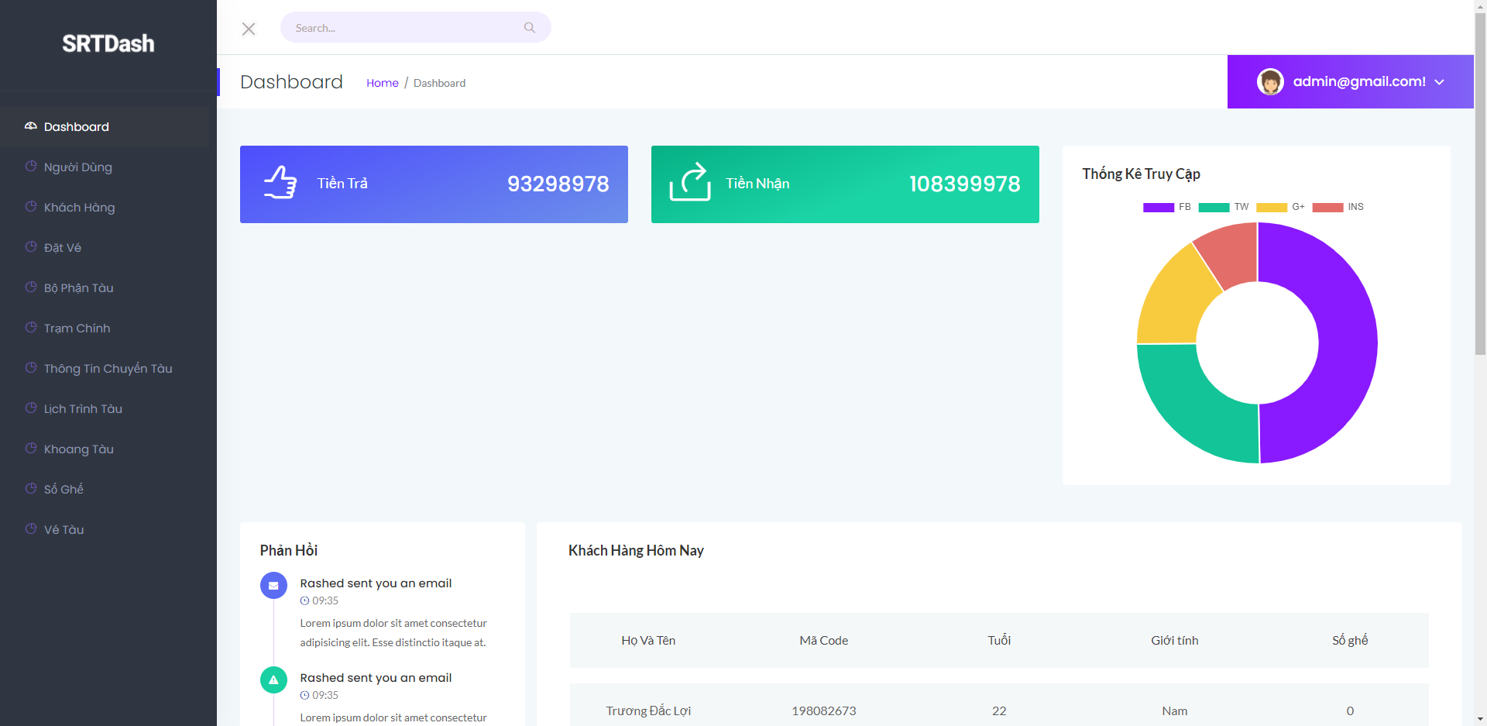

1. ***Manage Staff (Administrators)***

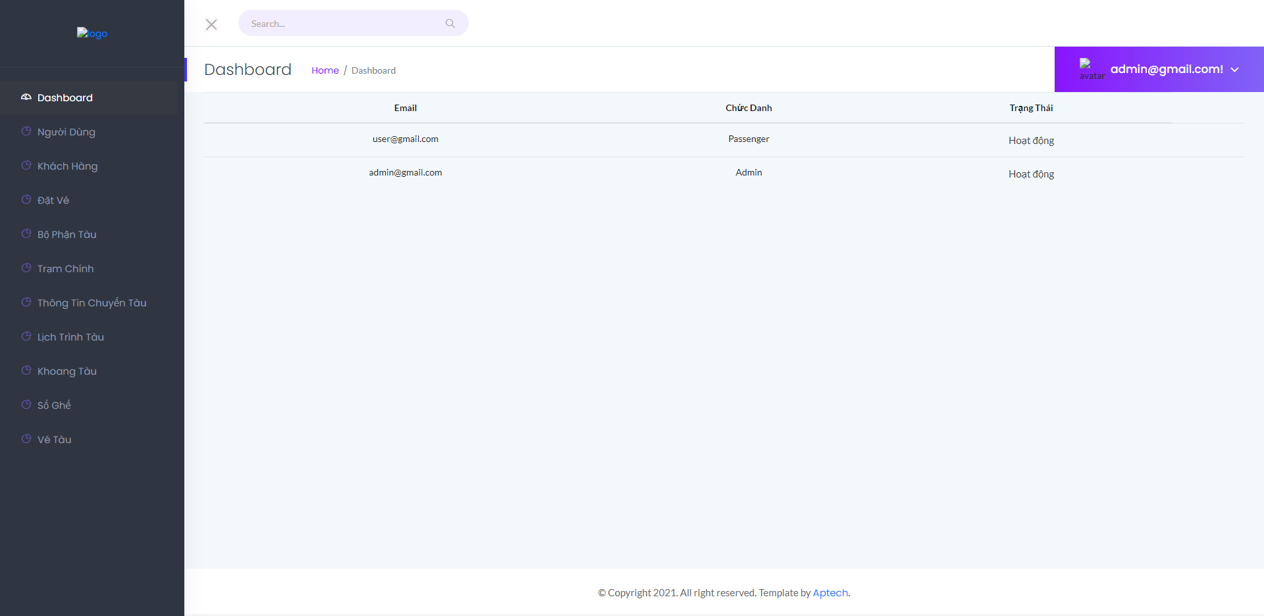

1. ***Manage Customer***

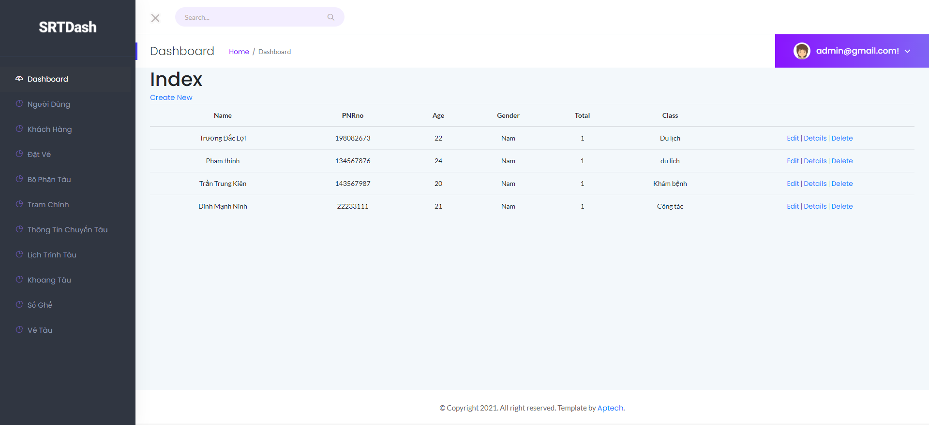

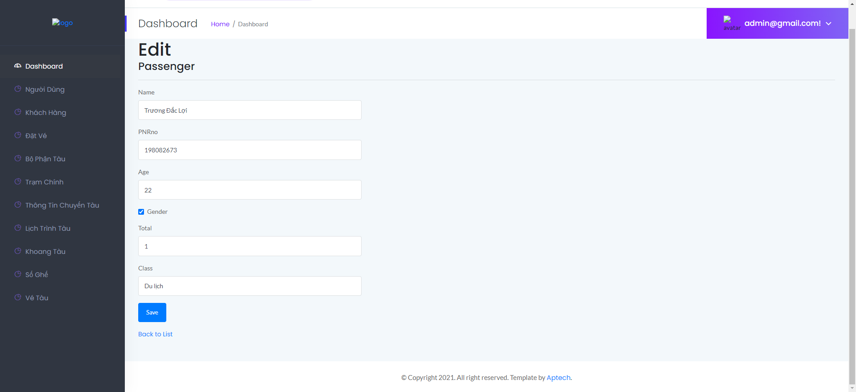

1. ***Booking train***

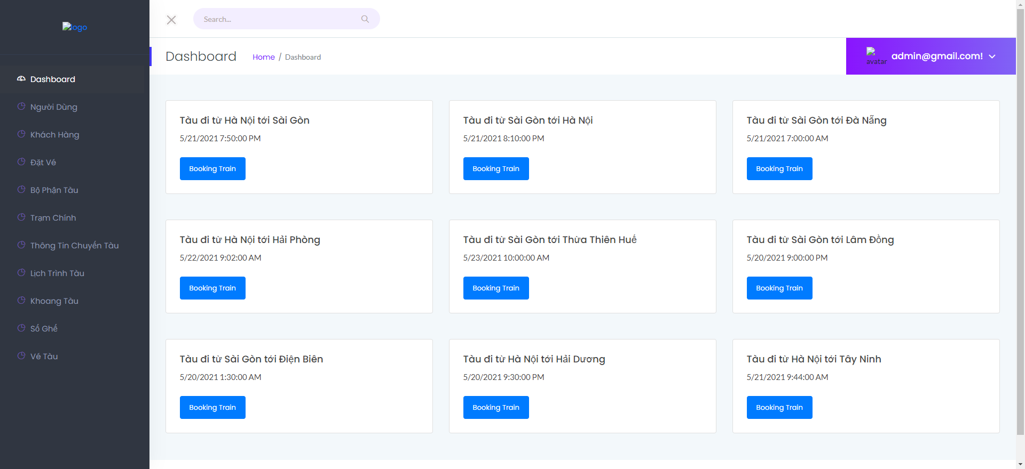

1. ***Railway name***

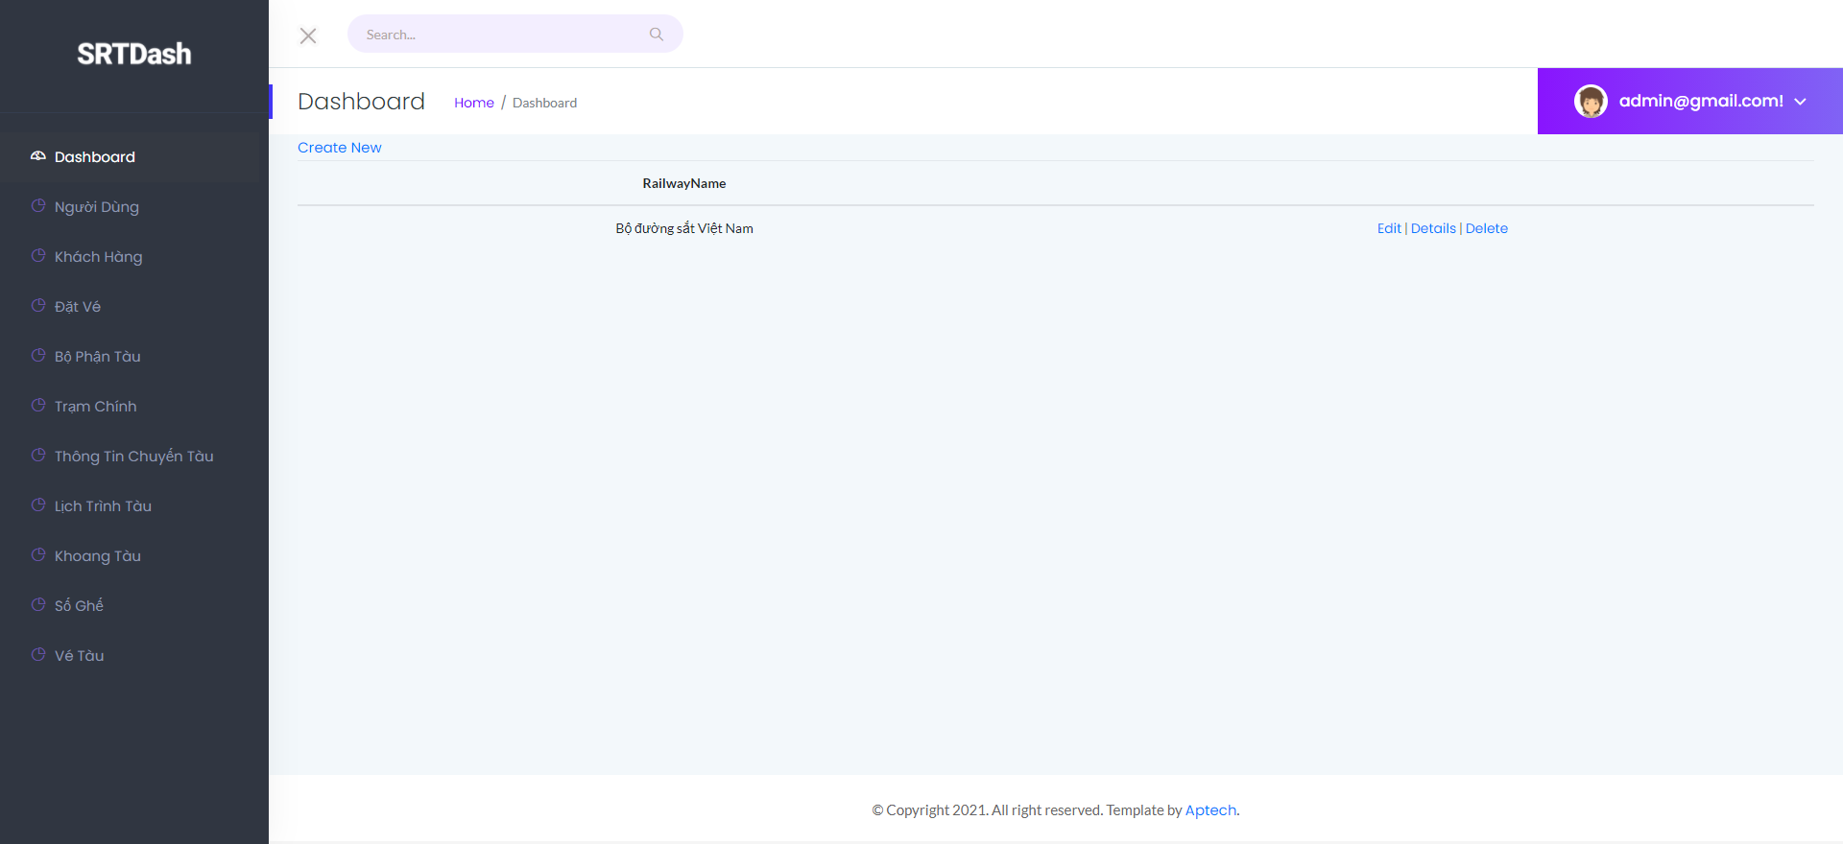

1. ***Main Station***

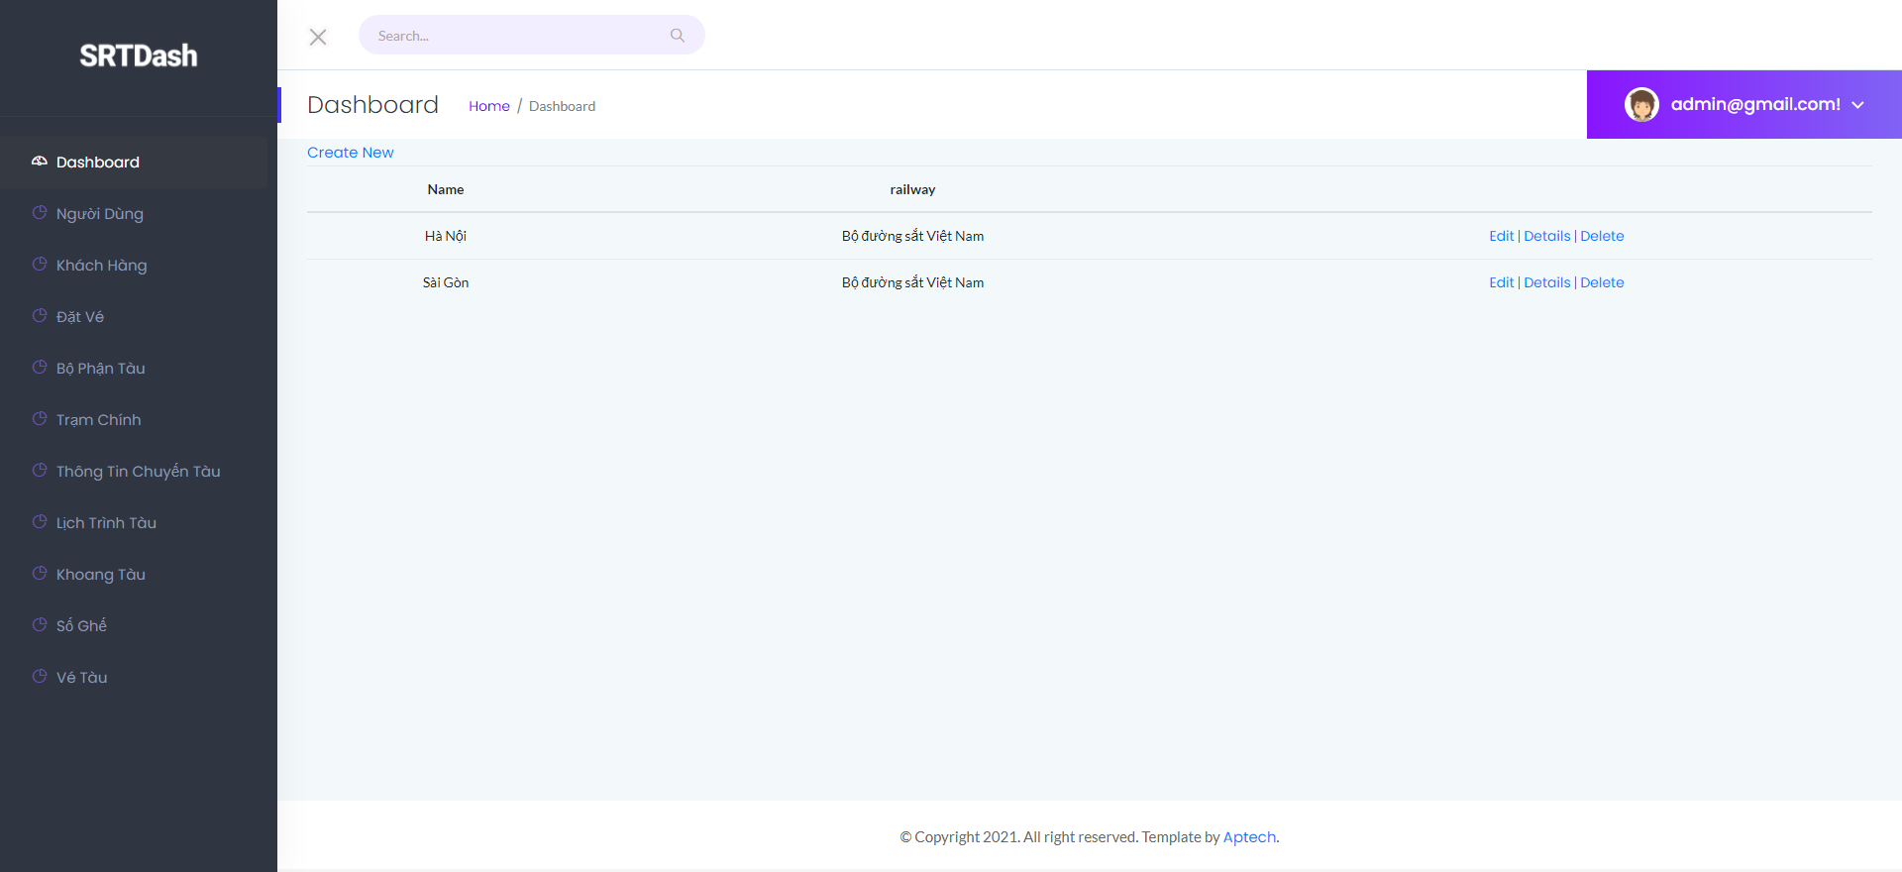

1. ***Information of the train***

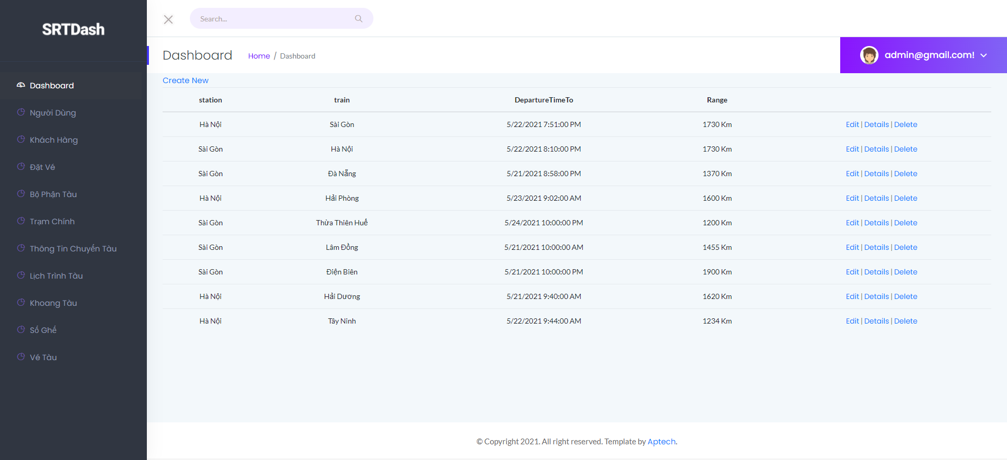

1. ***Train schedule***

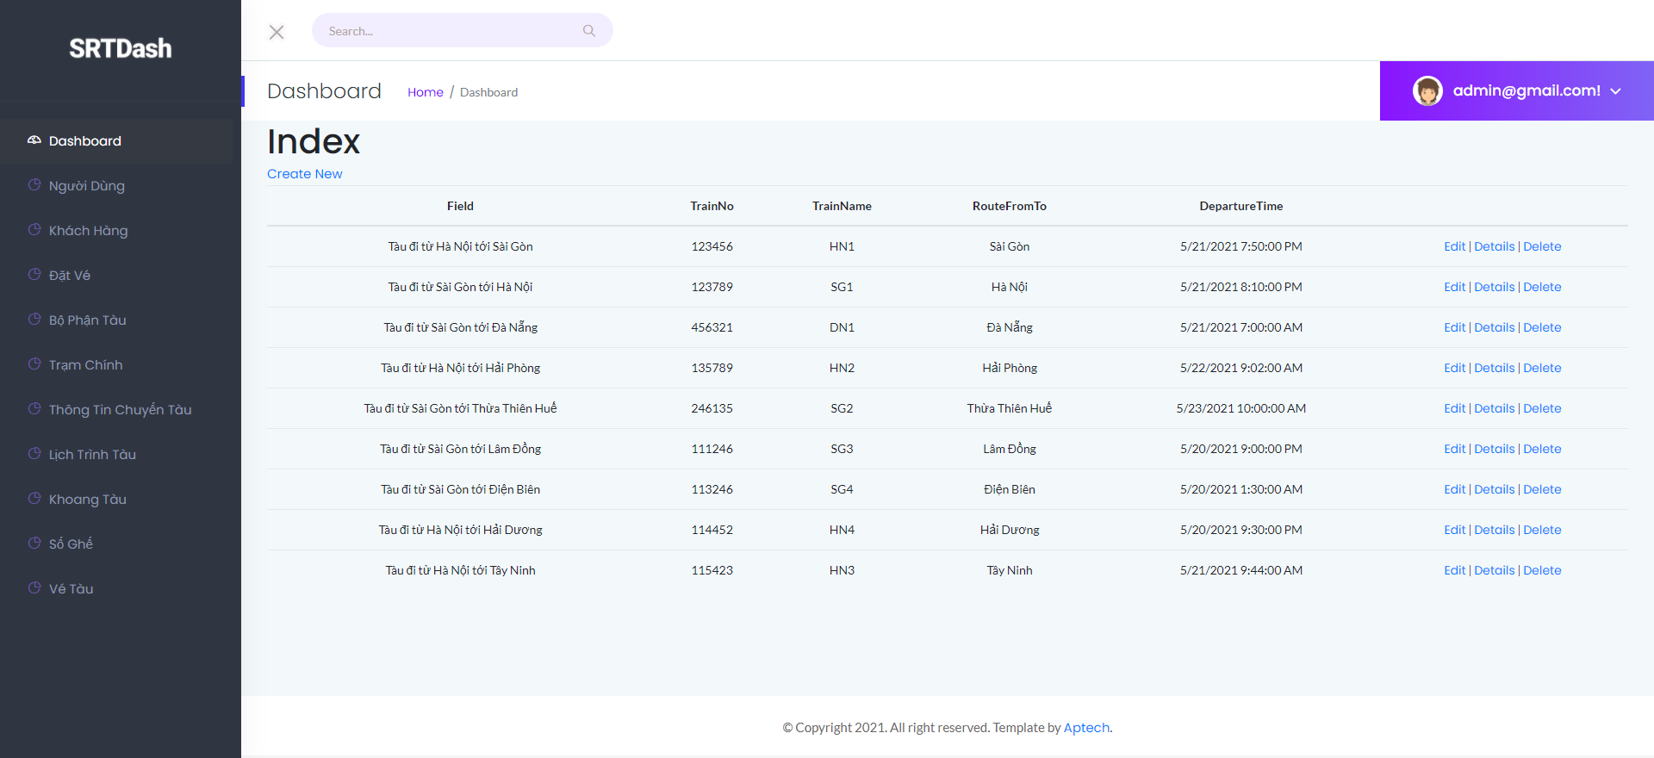

1. ***Train drill***

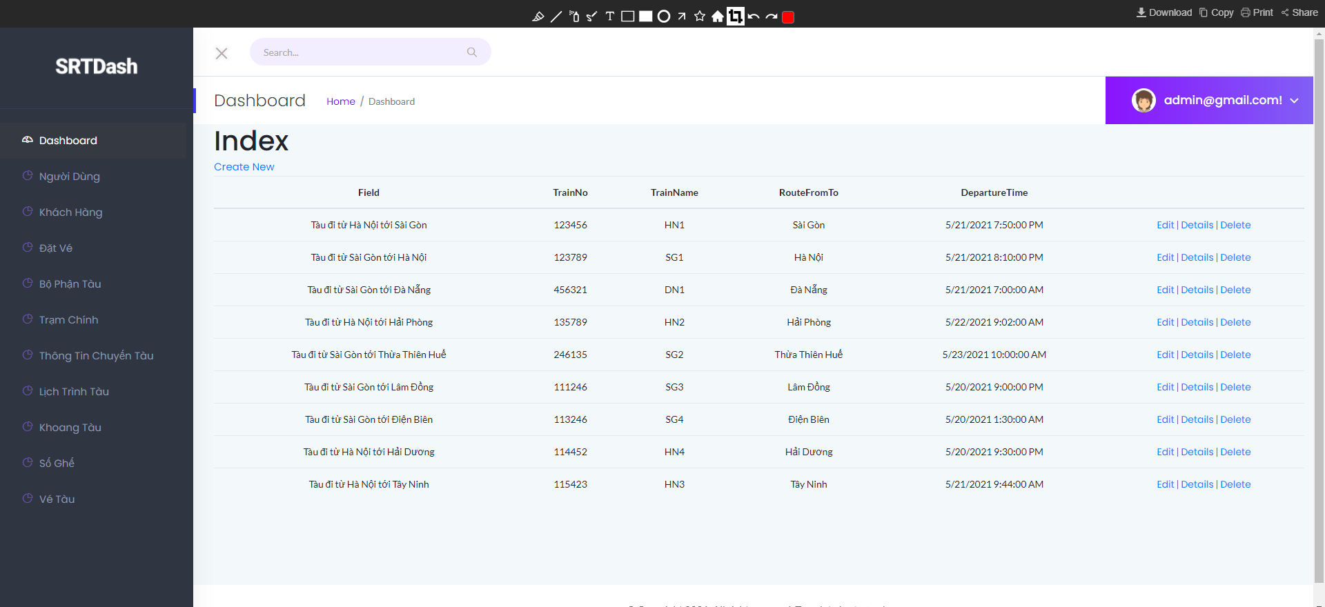

1. ***Seat Number***

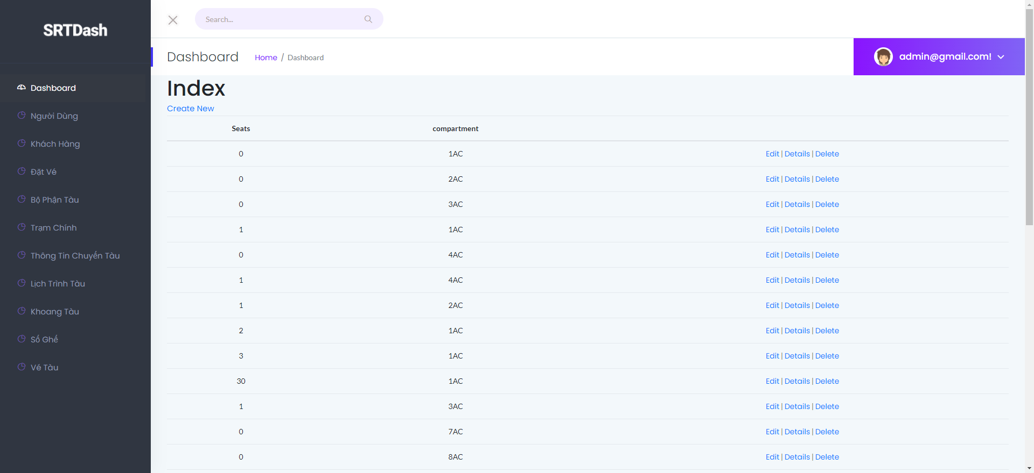

1. ***Manage Payment Method***

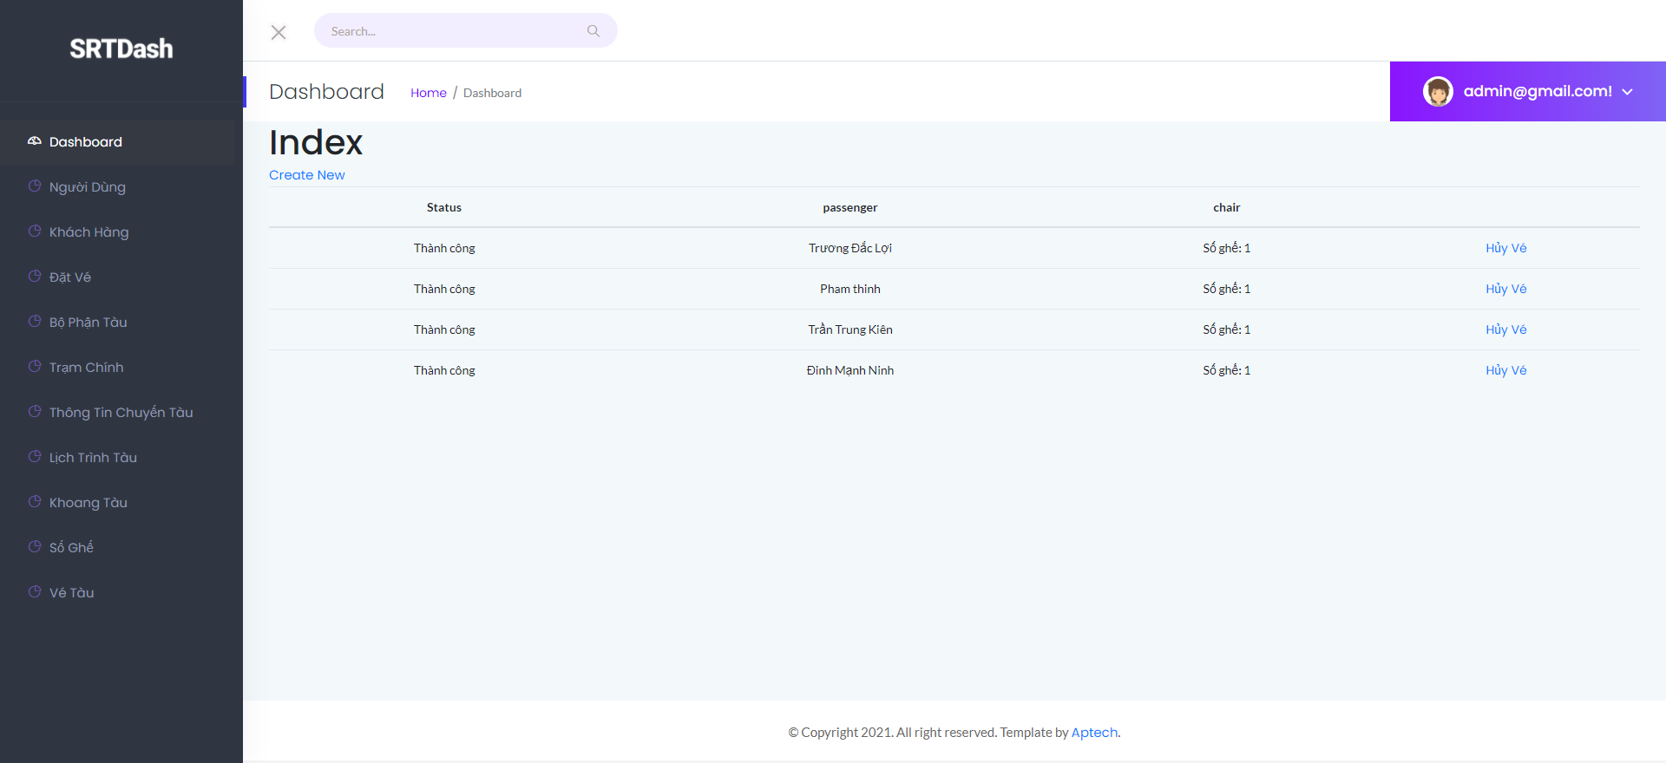

1. ***Train Route***

